

Pillai College of Engineering, New Panvel
Department of Computer Engineering

A.Y. 2025-26
Subject Name: Web Programming

Under the guidance of
Prof. Nishant Shankar

Mini Project Report on
“TeleMed Connect”
Smart Telemedicine Platform

Presented by: Sneha Pillai Amit Pundekar Mudassir Shaikh Ritesh Singh

Project Overview

  - Problem Statement
India has 140 crore people but only 12 lakh registered doctors — approximately 1 doctor per 1,000 people. The World Health Organization recommends a minimum of 1 doctor per 1,000 people. However, the critical issue is distribution: 80% of doctors are concentrated in cities while 70% of India's population lives in rural areas.
Existing telemedicine solutions like Apollo247 and Practo are complex, expensive, and assume every patient has a smartphone and reliable internet access. Key problems identified:
    - Patients in rural areas cannot physically reach doctors
    - Urban-only telemedicine platforms ignore 70% of India's population
    - Language barriers prevent effective doctor-patient communication
    - No quick emergency medical location sharing system
    - No AI-powered guidance before consultation to reduce unnecessary bookings
    - Disconnected appointment, prescription, and payment systems
    - No digital prescription management with direct medicine ordering

  - Our Solution — TeleMed Connect
TeleMed Connect is a full-stack telemedicine web application that connects patients with verified doctors for remote consultations. It solves all identified problems through a single integrated platform:
    - AI-powered symptom analysis with probability scores, home remedies, and diet tips
    - Digital prescriptions with branded PDF download and direct medicine ordering
    - Multilingual real-time chat supporting Hindi, Marathi, Tamil, and Telugu
    - Emergency SOS with GPS location sharing and helpline integration
    - Razorpay payment gateway for secure online consultation fee payment
    - Jitsi Meet video consultation embedded directly in the platform
    - Lab report upload and sharing between patient and doctor
    - Doctor reviews and ratings for quality assurance
    - Visual appointment calendar with health analytics dashboard
    - Admin panel for doctor approval and platform management

  - Three Unique Features

Feature | What It Does | Why It Is Unique
Ask Before You Book | 5-question scoring algorithm tells patients if they actually need a doctor before booking | No other telemedicine app tells you IF you need a doctor — they all just push you to book immediately
Emergency SOS with GPS | Hold-to-activate 3-second button captures GPS coordinates and shows helplines 112/108/104 with exact location | One-tap emergency with real GPS coordinates — works even when the patient cannot speak

Multilingual Chat | Real-time translation in Hindi, Marathi, Tamil, Telugu using MyMemory API — both original and translated stored in Firestore | Removes the biggest barrier in Indian rural healthcare — language difference between doctor and patient

Architecture and Design

  - Technology Stack

Layer | Technology | Purpose
Frontend | React 18 + Vite | Component-based UI. Vite provides instant Hot Module Replacement
Language | JavaScript ES6+ | async/await, arrow functions, destructuring, template literals
Styling | CSS3 — Flexbox, Grid, Animations | 3 responsive breakpoints, @keyframes animations, CSS variables
Routing | React Router DOM | 20+ pages with client-side navigation and PrivateRoute protection
Authentication | Firebase Authentication | Email/password login, JWT sessions, role-based redirect
Database | Cloud Firestore (NoSQL) | Real-time updates, 6 collections, 50K reads/day free tier
File Storage | Firebase Storage | Lab report upload with progress tracking, public URL generation
Hosting | Firebase Hosting | One-command deploy, automatic HTTPS/SSL, global CDN
Payment | Razorpay SDK | UPI, Cards, NetBanking — Indian payment gateway
Video | Jitsi Meet | Free open-source video, no API key, shared room via appointment ID
PDF Generation | jsPDF | Browser-based branded prescription PDF, loaded from CDN
Notifications | react-hot-toast | Success and error toast alerts throughout the application
Version Control | Git + GitHub | 30+ commits tracking weekly progress, team collaboration
AI / ML | Gemini API + SMART_DB fallback | AI symptom analysis with probability scores, home remedies, diet tips. Smart keyword fallback covers 8 medical categories

  - System Architecture
TeleMed Connect follows a client-side rendering architecture with Firebase as the serverless backend:
    - Frontend: React + Vite SPA (Single Page Application) deployed on Firebase Hosting
    - Backend: Firebase BaaS (Backend as a Service) — no custom server required
    - Database: Cloud Firestore NoSQL — collections for users, doctors, patients, appointments, prescriptions, chats, reviews, lab reports
    - File Storage: Firebase Storage for lab report PDFs and images
    - Authentication: Firebase Auth with JWT tokens for session management
    - External APIs: Razorpay (payment), MyMemory (translation), Jitsi Meet (video), jsPDF (PDF generation)

  - Database Design — Firestore Schema

Collection | Document ID | Key Fields
users | Firebase Auth UID | email, role ('patient'/'doctor'), displayName, createdAt
patients | Firebase Auth UID | fullName, phone, bloodGroup, dateOfBirth, allergies, medicalHistory
doctors | Firebase Auth UID | fullName, specialization, licenseNumber, consultationFee, experience, rating, approved
appointments | Auto-generated ID | patientId, doctorId, appointmentDate, appointmentTime, reason, status, paymentId, createdAt
prescriptions | Auto-generated ID | patientId, doctorId, diagnosis, notes, medicines[{name, dosage, frequency, duration}], createdAt
chats | chatId/messages/msgId | senderId, receiverId, originalText, translatedText, originalLanguage, timestamp
reviews | Auto-generated ID | doctorId, patientId, rating (1-5), comment, createdAt
labReports | Auto-generated ID | patientId, reportName, reportType, fileURL, fileSize, createdAt

  - Module Structure

Module / File | Responsibility
src/App.jsx | All routes defined. PrivateRoute protects authenticated pages. RoleRedirect sends users to correct dashboard.
src/firebase/config.js | Firebase initialization. Exports auth, db, storage used by all other files.
src/context/AuthContext.jsx | Global user state using Context API. onAuthStateChanged detects login/logout. Provides user+role everywhere.
src/components/Layout.jsx | Shared sidebar, top bar, all CSS with 3 responsive breakpoints, all @keyframes animations. Used by all 20+ pages.

src/components/PaymentGateway.jsx | Razorpay payment integration. Loads SDK dynamically. Handles payment flow and saves paymentId to Firestore.
src/pages/PatientDashboard.jsx | Fetches real appointment stats from Firestore. Shows upcoming, confirmed, completed counts.
src/pages/BookAppointment.jsx | 14 time slots, date picker, reason textarea. Experiment 4 form validation. Razorpay payment before booking.
src/pages/HealthCenter.jsx | AI Symptom Checker with probability scores, home remedies, diet tips. Ask Before You Book scoring algorithm.
src/pages/Chat.jsx | Real-time Firestore messaging with onSnapshot. MyMemory API for translation. Saves both original + translated text.
src/pages/HospitalsEmergency.jsx | Emergency SOS hold-to-activate. GPS geolocation. 5-second countdown. Helplines 112/108/104.
src/pages/VideoCall.jsx | Jitsi Meet video consultation. Opens shared room using appointment ID. No API key needed.
src/pages/PDFPrescription.jsx | Downloads branded A4 prescription PDF using jsPDF. Doctor info, medicines, dosage, footer.
src/pages/LabReports.jsx | Firebase Storage upload with progress bar. Drag-drop interface. Doctor views patient reports.
src/pages/AdminPanel.jsx | Super admin manages doctors and patients. Approve or suspend doctors. View all appointments.

APIs Used and Integrated

  - Firebase APIs (Google)

Firebase Authentication
    - File: src/context/AuthContext.jsx, src/pages/Login.jsx, src/pages/Register.jsx
    - Functions used: signInWithEmailAndPassword(), createUserWithEmailAndPassword(), onAuthStateChanged()
    - Purpose: Secure user login and registration. JWT token management. Session persistence.
    - Key: Firebase project API key in src/firebase/config.js (firebaseConfig.apiKey)

Cloud Firestore
    - File: All pages that fetch or save data
    - Functions used: getDocs(), addDoc(), setDoc(), updateDoc(), deleteDoc(), onSnapshot(), query(), where(), orderBy()
    - Purpose: Store all application data — users, appointments, prescriptions, chats, reviews, lab reports

Firebase Storage
    - File: src/pages/LabReports.jsx
    - Functions used: ref(), uploadBytesResumable(), getDownloadURL()
    - Purpose: Upload lab report files (PDF, images). Progress tracking. Public URL generation.

  - Razorpay Payment API
    - File: src/components/PaymentGateway.jsx
    - Integration: Script loaded dynamically from https://checkout.razorpay.com/v1/checkout.js
    - Key stored in: .env file as VITE_RAZORPAY_KEY_ID (not committed to GitHub)
    - Accessed in code: import.meta.env.VITE_RAZORPAY_KEY_ID
    - Flow: Patient clicks pay → Razorpay popup opens → UPI/Card/NetBanking → onSuccess saves paymentId to Firestore appointment
    - Test credentials: Card 4111 1111 1111 1111, UPI: success@razorpay

  - MyMemory Translation API
    - File: src/pages/Chat.jsx
    - Endpoint: https://api.mymemory.translated.net/get?q={text}&langpair=en|{lang}
    - Integration: Browser Fetch API — fetch(url) → response.json() → data.responseData.translatedText
    - Key: No API key required — free public API
    - Languages supported: Hindi (hi), Marathi (mr), Tamil (ta), Telugu (te)
    - Data storage: Both originalText and translatedText saved to Firestore for each message

  - Jitsi Meet Video API
    - File: src/pages/VideoCall.jsx
    - Integration: Opens https://meet.jit.si/{roomName} in a new browser tab
    - Room name generated as: 'TeleMedConnect-' + appointmentId (unique per appointment)
    - Key: No API key required — completely free and open-source
    - How both parties connect: Doctor and patient both navigate to the same
/video-call/{appointmentId} URL, generating the same room name, so they land in the same Jitsi room automatically

  - jsPDF Library
    - File: src/pages/PDFPrescription.jsx
    - Integration: Dynamically imported from CDN — const { jsPDF } = await import('https://cdnjs.cloudflare.com/ajax/libs/jspdf/2.5.1/jspdf.umd.min.js')
    - Key: No API key required — open-source library
    - Features used: Custom teal header with TeleMed branding, doctor info box, patient info, diagnosis section, medicines list with dosage tags, footer with URL
    - Output: pdf.save('Prescription_{patientName}_{date}.pdf') triggers browser download

  - Browser Geolocation API (Emergency SOS)
    - File: src/pages/HospitalsEmergency.jsx
    - Integration: navigator.geolocation.getCurrentPosition(callback) — built-in browser Web API
    - Key: No API key required — native browser capability
    - Returns: position.coords.latitude and position.coords.longitude
    - Usage: Displayed to patient after SOS activation so they can share their location with emergency services

  - AI Symptom Checker
    - File: src/pages/HealthCenter.jsx
    - Primary: Gemini API (Google) — endpoint: generativelanguage.googleapis.com/v1beta/models/gemini-2.0-flash:generateContent
    - Key stored in: .env file as VITE_GEMINI_API_KEY. Note: Due to free tier rate limits during testing, the system uses an intelligent SMART_DB fallback covering 8 medical categories with probability scores, home remedies, OTC medicines and red flags — ensuring the feature always works reliably.
    - Fallback: Smart keyword-based database (SMART_DB) built into the code — covers 8 medical categories: chest, headache, fever, stomach, breathing, skin, joint, mental
    - Output: Possible conditions with probability percentages, recommended specialist, urgency level, home remedies, diet tips, OTC medicines, red flags

Challenges Faced During Development

# | Challenge | Problem | How We Solved It
1 | Role-Based Routing | Ensuring doctors and patients cannot access each other's pages even if logged in | Built PrivateRoute component with doctorOnly and patientOnly props that checks role from Firestore and redirects unauthorized users
2 | Gemini API Rate Limits | Free Gemini API key hits 429 Too Many Requests error during testing | Built a comprehensive SMART_DB fallback with 8 medical categories, probability scores, home remedies, and diet tips that always works without any API
3 | Real-Time Chat Translation | Translating messages without delaying the user experience and storing both versions | Used async translation with await before addDoc() so both originalText and translatedText are saved together in one Firestore write
4 | Razorpay GitHub Push Protection | GitHub blocked push because  .env file with API keys was accidentally committed | Used git rm --cached .env to remove from tracking, added  .env to .gitignore, used git push  --force after allowing the secret on GitHub
5 | Jitsi Meet Embedding | Embedding Jitsi inside an iframe caused 'Asking to join' stuck screen due to free server queue | Changed approach to open Jitsi in a new tab instead of iframe. Both parties share the same room URL generated from appointmentId
6 | Mobile Responsive Layout | Using * { max-width:100% } to fix mobile broke sidebar sliding animations | Removed the universal selector and added targeted CSS classes (cal-grid, lab-stats-grid, analytics-stats) specific to each page instead
7 | Missing Routes for New Features | Lab Reports, PDF Prescription, and Doctor Reviews pages redirected to Landing page when clicked | Diagnosed missing import and Route declarations in App.jsx. Added all three routes and imports — clicking now navigates correctly
8 | Firebase Storage CORS | Lab report uploads failed with CORS error when accessing Firebase Storage from deployed URL | Configured Firebase Storage security rules to allow authenticated reads and writes. Tested with uploadBytesResumable and confirmed upload progress works correctly
9 | PDF File Copy Not Working | Windows copy command in CMD was not replacing project | Used Python script approach with open(file, 'w',

 |  | files — downloads were going to wrong location | encoding='utf-8') to write files directly, bypassing Windows file copy restrictions
10 | Async/Await in Component Scope | Accidentally pasted async code outside the function scope causing 'await can only be used inside async function' build error | Used git checkout HEAD -- filename to restore the broken file to its last working committed version, then reapplied the fix correctly inside the async function

- Contributions of Each Team Member

  - Sneha Pillai — Team Lead & Frontend Architecture

Area | Contribution
Project Setup | Initialized React + Vite project, installed all dependencies (Firebase, React Router, react-hot-toast), configured Firebase project with Auth + Firestore  + Storage + Hosting
UI Design System | Designed teal color scheme (#0d9488), Inter/Calibri fonts, CSS variables, card shadows, animation timings used throughout the application
Landing Page | Built hero section with animated stats counter using setInterval, features grid, specializations section, footer
Patient & Doctor Dashboard | Fetched real Firestore data for appointment statistics, health tip of the day widget, quick action cards
Layout Component | Built shared Layout.jsx used by all 20+ pages — sidebar, hamburger toggle, top bar, teal color scheme
Role-Based Routing | Implemented PrivateRoute in App.jsx with doctorOnly/patientOnly props, RoleRedirect component
Razorpay Integration | Built PaymentGateway.jsx — dynamic script loading, Razorpay instance creation, onSuccess saving paymentId to Firestore
Jitsi Video Call | Built VideoCall.jsx — shared room generation from appointmentId, opens in new tab, pre-call info screen
New Features | Built AppointmentCalendar.jsx, HealthAnalytics.jsx, AdminPanel.jsx
Deployment & GitHub | Deployed to Firebase Hosting, managed all git commits (30+), wrote project README.md
Files Owned | App.jsx, Layout.jsx, Landing.jsx, PatientDashboard.jsx, DoctorDashboard.jsx, PaymentGateway.jsx, VideoCall.jsx, AppointmentCalendar.jsx, HealthAnalytics.jsx, AdminPanel.jsx, README.md

  - Amit — Backend & Firebase Developer

Area | Contribution
Firestore Schema | Designed all 6 database collections: users, doctors, patients, appointments, prescriptions, chats with all fields
Firebase Authentication | Built Register.jsx (createUserWithEmailAndPassword + dual setDoc to users + doctors/patients), Login.jsx (signInWithEmailAndPassword + role fetch + redirect), AuthContext.jsx (onAuthStateChanged)
Book Appointment (Exp 4) | 14 clickable time slots, date picker, reason textarea. validateDate() checks past dates. validateTime() checks slot selection. validateReason() requires 10+ chars. All validate onChange in real-time

Doctor Appointments | Confirm/Decline/Complete workflow with updateDoc(). Local state updates immediately for instant feedback without re-fetch
Prescription System | Dynamic medicine rows with add/remove. Dosage, frequency, duration fields. 1mg and PharmEasy order links using medicine name as search query
Patient Appointments | Filter tabs for All, Pending, Confirmed, Completed, Cancelled using Array.filter(). Health records timeline combining appointments + prescriptions sorted by createdAt
Files Owned | firebase/config.js, context/AuthContext.jsx, Register.jsx, Login.jsx, BookAppointment.jsx, DoctorAppointments.jsx, Prescription.jsx, PatientAppointments.jsx

  - Mudassir — UI/UX & Responsive Design

Area | Contribution
Responsive CSS (Exp 3) | 3 @media breakpoints in Layout.jsx: phone under 600px (sidebar hides, 1-column grids), tablet 600-991px (2-column), desktop above 992px (sidebar always visible, 3-4 column grids)
CSS Animations (Exp 3) | @keyframes fadeUp (cards rise on load), slideInLeft (sidebar enters), pulse (online indicator breathes), spin (loading spinners rotate). All use animation property with duration and easing
Sidebar Navigation | Hamburger button toggles open/closed state. CSS transforms translateX(-100%) to hide, translateX(0) to show. Overlay closes sidebar on mobile tap
Accessibility | aria-label on icon buttons, aria-expanded on hamburger,  aria-current='page' on active nav link, prefers-reduced-motion media query disables all animations for sensitive users
Page Designs | Login and Register with professional two-column layout. Search Doctors with filters sidebar and results grid. All pages use consistent teal color scheme
Mobile Fixes | Added targeted CSS classes (cal-grid, lab-stats-grid, analytics-charts) to make Calendar, Lab Reports, and Health Analytics responsive without breaking animations
Files Owned | components/Layout.jsx (all CSS), components/PatientSidebar.jsx, components/DoctorSidebar.jsx, pages/Login.jsx, pages/Register.jsx, pages/SearchDoctors.jsx

  - Ritesh — Special Features, Testing & Documentation

Area | Contribution
Emergency SOS (Exp 5/6) | onMouseDown sets holding=true. useEffect + setInterval increments holdProgress 5% every 150ms (3 seconds). activateSOS() calls navigator.geolocation.getCurrentPosition(). Shows GPS, helplines 112/108/104

Multilingual Chat | MyMemory API fetch() with langpair parameter (Experiment 5). Firestore onSnapshot() for real-time updates (Experiment 6). Stores originalText + translatedText. Supports 4 Indian languages
Ask Before You Book | 5-question wizard with urgent/consult/selfcare scoring. Thresholds: urgent>=3 → Seek Care, consult>=2 → Consultation, else → Self-Care. Auto-advances 250ms after answer
Medication Tracker | Weekly 7-day grid with taken/not-taken toggle. Adherence percentage calculated and displayed as SVG ring chart with stroke-dasharray and stroke-dashoffset
Lab Reports | Firebase Storage uploadBytesResumable() with progress tracking. Drag-drop zone with dragOver state. getDownloadURL() saves URL to Firestore labReports collection
Doctor Reviews | 5-star interactive rating with hover effects. Minimum 10 character review. Average rating and distribution bar chart. Prevents duplicate reviews per patient
PDF Prescriptions | Dynamic jsPDF import from CDN. Branded A4 PDF: teal header, doctor box, patient box, diagnosis section, numbered medicines with dosage pills, footer with URL
Files Owned | HospitalsEmergency.jsx, Chat.jsx, MyPrescriptions.jsx, LabReports.jsx, DoctorReviews.jsx, PDFPrescription.jsx, VideoCall.jsx, README.md

Application Flow And Screenshots— Feature Descriptions

# | Page / Feature | What User Sees | Technical Details
1 | Landing Page | Hero banner with headline, animated stats counter (0 to 1400+ doctors), features grid, specializations, footer with links | setInterval animates counter. CSS Grid for features. Public route — no login needed
2 | Register | Role selector (Patient or Doctor) with card highlight. Name, email, password fields. Redirects to dashboard on success | createUserWithEmailAndPassword()  + setDoc() to users + doctors/patients collections simultaneously
3 | Login | Email and password fields.  Role-based redirect — doctors go to /doctor-dashboard, patients go to /patient-dashboard | signInWithEmailAndPassword() + getDoc() to fetch role + useNavigate() for redirect
4 | Patient Dashboard | Stat cards: Upcoming, Confirmed, Completed appointments. Recent appointments list. Health tip of the day | getDocs() with where('patientId','==',user.uid) + Array calculations for stats
5 | Find Doctors | Filters: specialization, experience, fee range. Doctor cards with rating and book button | getDocs(collection(db,'doctors')) + client-side filter with Array.filter()
6 | Book Appointment | Doctor info card, 14 clickable time slots, date picker, reason textarea, Razorpay payment popup, confirmation screen | Real-time form validation (Exp 4) + PaymentGateway.jsx + addDoc() after payment success
7 | Doctor Appointments | Cards per appointment with Confirm, Decline, Complete buttons. Chat and Join Video Call buttons on confirmed appointments | updateDoc() changes status field. Local state update for instant UI feedback
8 | Write Prescription | Diagnosis input, doctor notes, dynamic medicine rows with name/dosage/frequency/duration, 1mg and PharmEasy order links | Dynamic array state with push/splice for medicine rows. addDoc() to prescriptions collection
9 | AI Symptom Checker | Age, gender, symptoms input. Results: possible conditions with % probability bars, triage level, home remedies, diet tips, OTC medicines, red flags | Gemini API with fallback to SMART_DB. 8 medical categories. Probability-based display
10 | Emergency SOS | Red hold button (hold 3 seconds to activate). Progress ring fills. GPS coordinates shown. Helplines 112/108/104 displayed | onMouseDown + setInterval + navigator.geolocation.  Hold-to-activate prevents accidents
11 | Multilingual Chat | Message input with language selector. Real-time messages in | MyMemory API fetch (Exp 5). Firestore onSnapshot() real-time listener (Exp 6)

 |  | selected language. Both original and translated text shown
12 | Video Consultation | Pre-call screen with appointment details. Join button opens Jitsi Meet in new tab. Both parties join same private room | Room = 'TeleMedConnect-' + appointmentId. window.open() to Jitsi URL. No API key needed
13 | PDF Prescription | Prescription preview card with doctor/patient info, diagnosis, medicines. Download PDF button generates branded A4 file | jsPDF dynamic import from CDN. pdf.save() triggers browser download
14 | Lab Reports | Stats cards (total, this month, types). Upload zone (click or drag-drop). Progress bar during upload. Reports list with View button | Firebase Storage uploadBytesResumable() with onProgress. getDownloadURL() saves to Firestore
15 | Doctor Reviews | Average rating with star display. Rating distribution bars (5,4,3,2,1 stars). Write review form with star selector and text | Firestore reviews collection. Average calculated in JS. One review per patient enforced
16 | Health Analytics | 4 stat cards (total visits, prescriptions, completed, upcoming). Appointment status breakdown. Bar charts for weight, glucose, BP | Fetches appointments + prescriptions. Bar chart heights calculated as percentage of max value
17 | Appointment Calendar | Monthly calendar grid with navigation. Colored dots on appointment dates. Click date to see day's appointments. Side panel with monthly stats | Dynamic grid generation from month/year. Date string matching for appointment lookup
18 | Admin Panel | Access restricted to admin email. Overview stats. Doctors tab with Approve/Suspend buttons.  Patients tab. Appointments tab with status | Fetches all 3 collections in parallel with Promise.all(). updateDoc({approved:true/false})

Figure 1: Landing Page Interface
Displays the homepage with hero section, platform features, and navigation options.
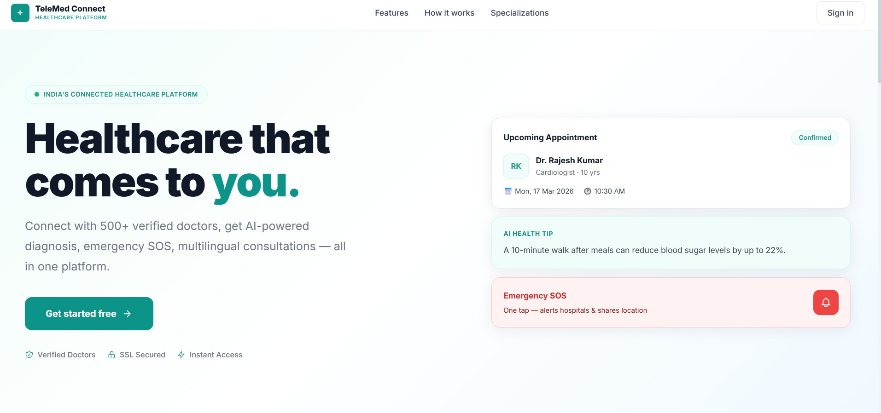

Figure 2: User Registration Page
Allows new users to register as a patient or doctor with required details.
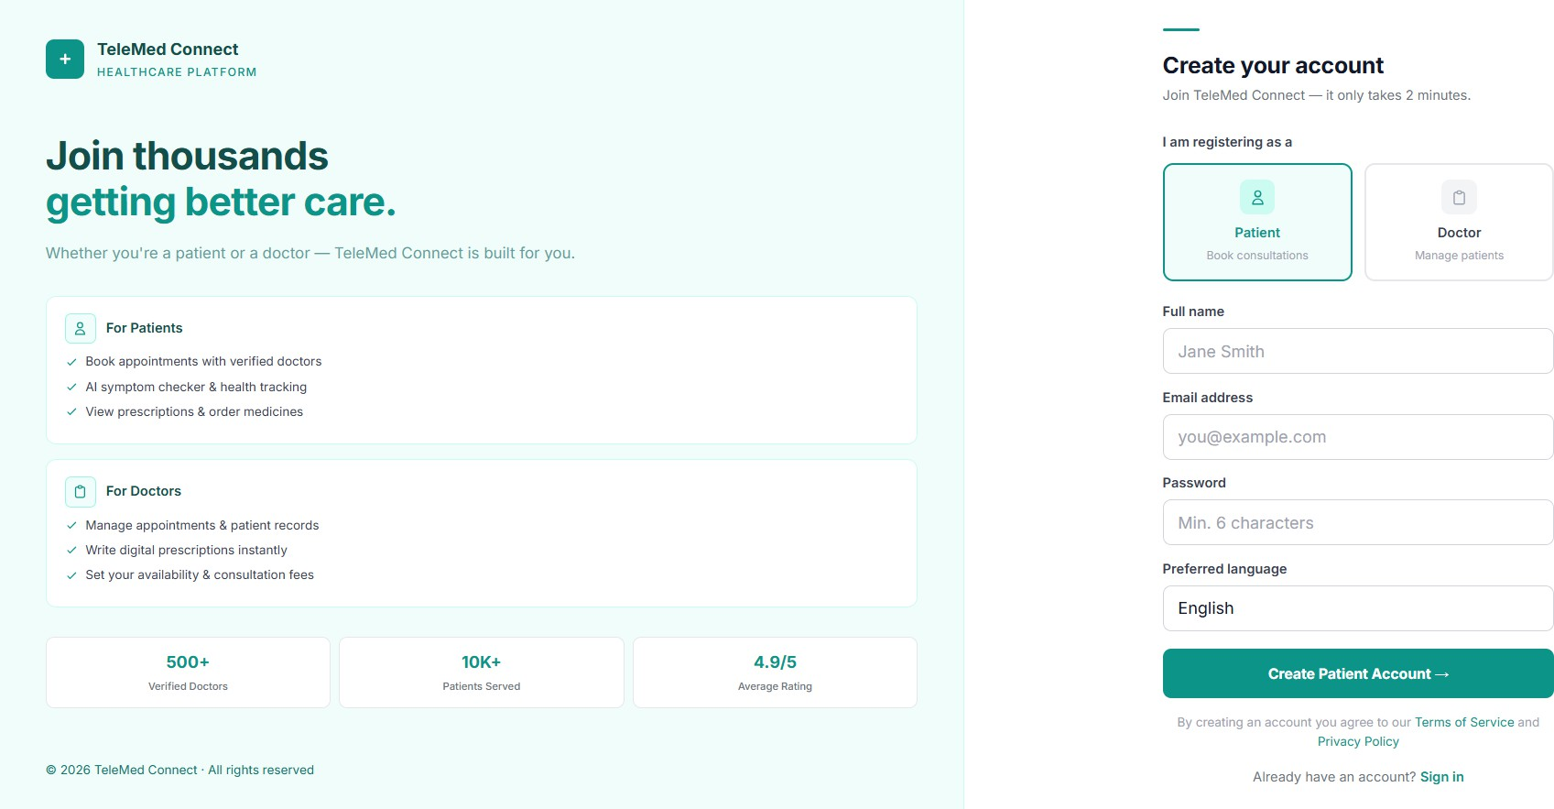

Figure 3: User Login Page
Secure login interface with role-based authentication and redirection.
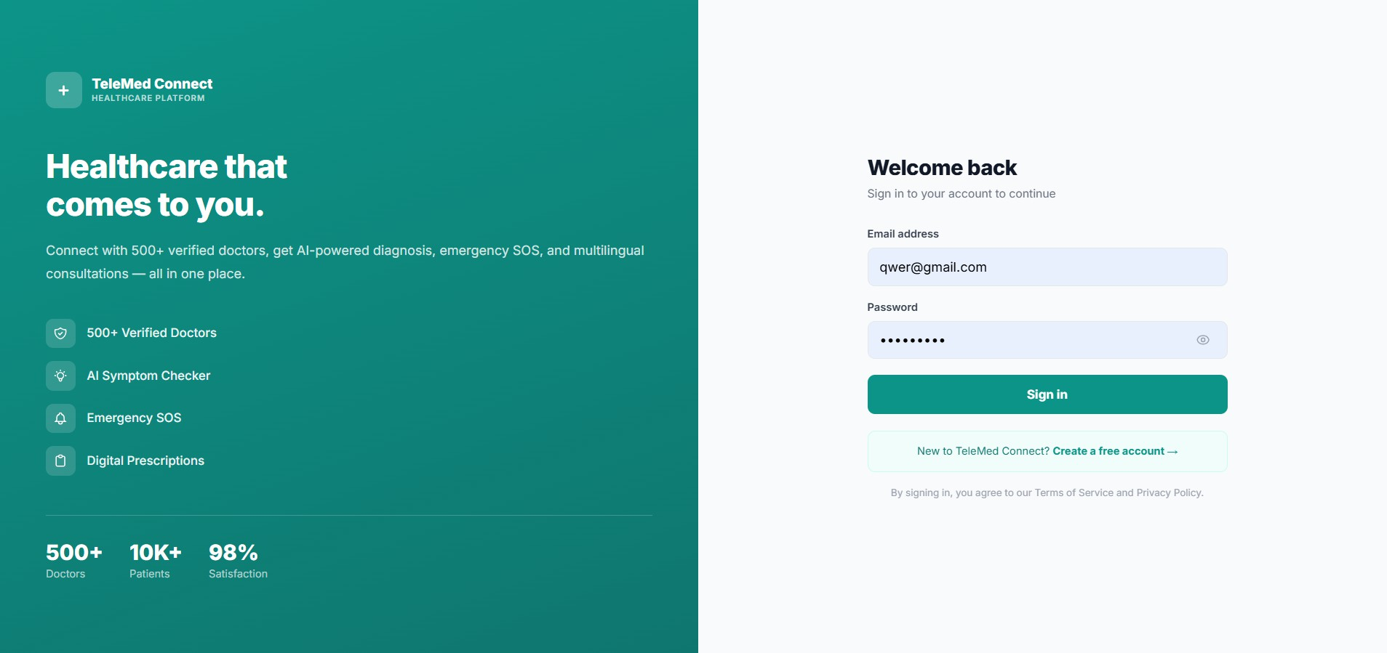

Figure 4: Patient Dashboard
Shows appointment statistics, recent activities, and quick action options.
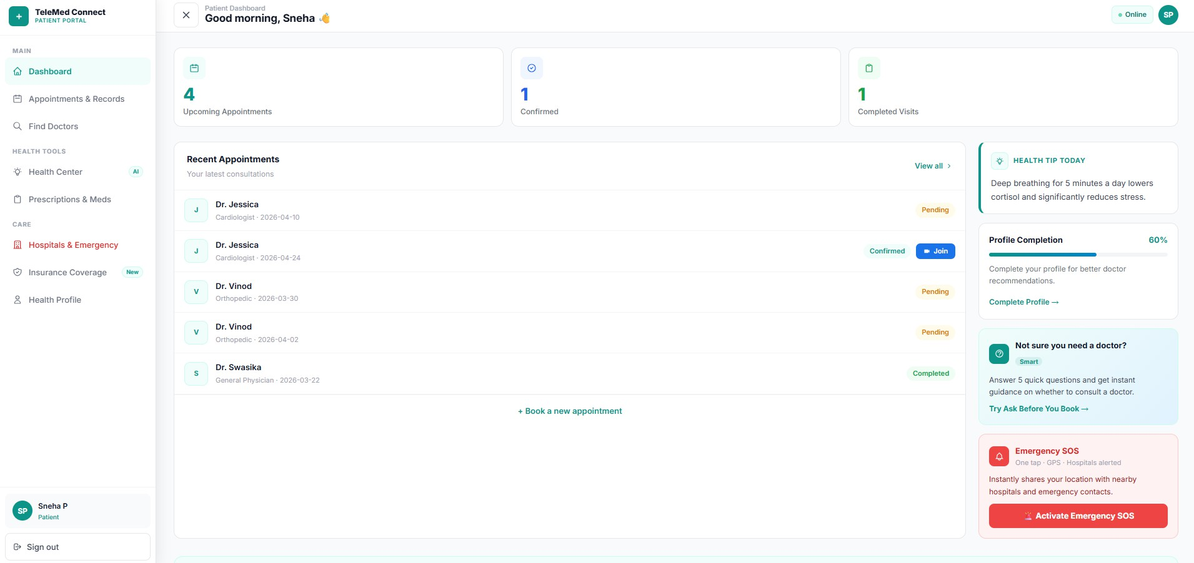

Figure 5: Doctor Dashboard
Displays doctor-specific data including appointments and patient interactions.
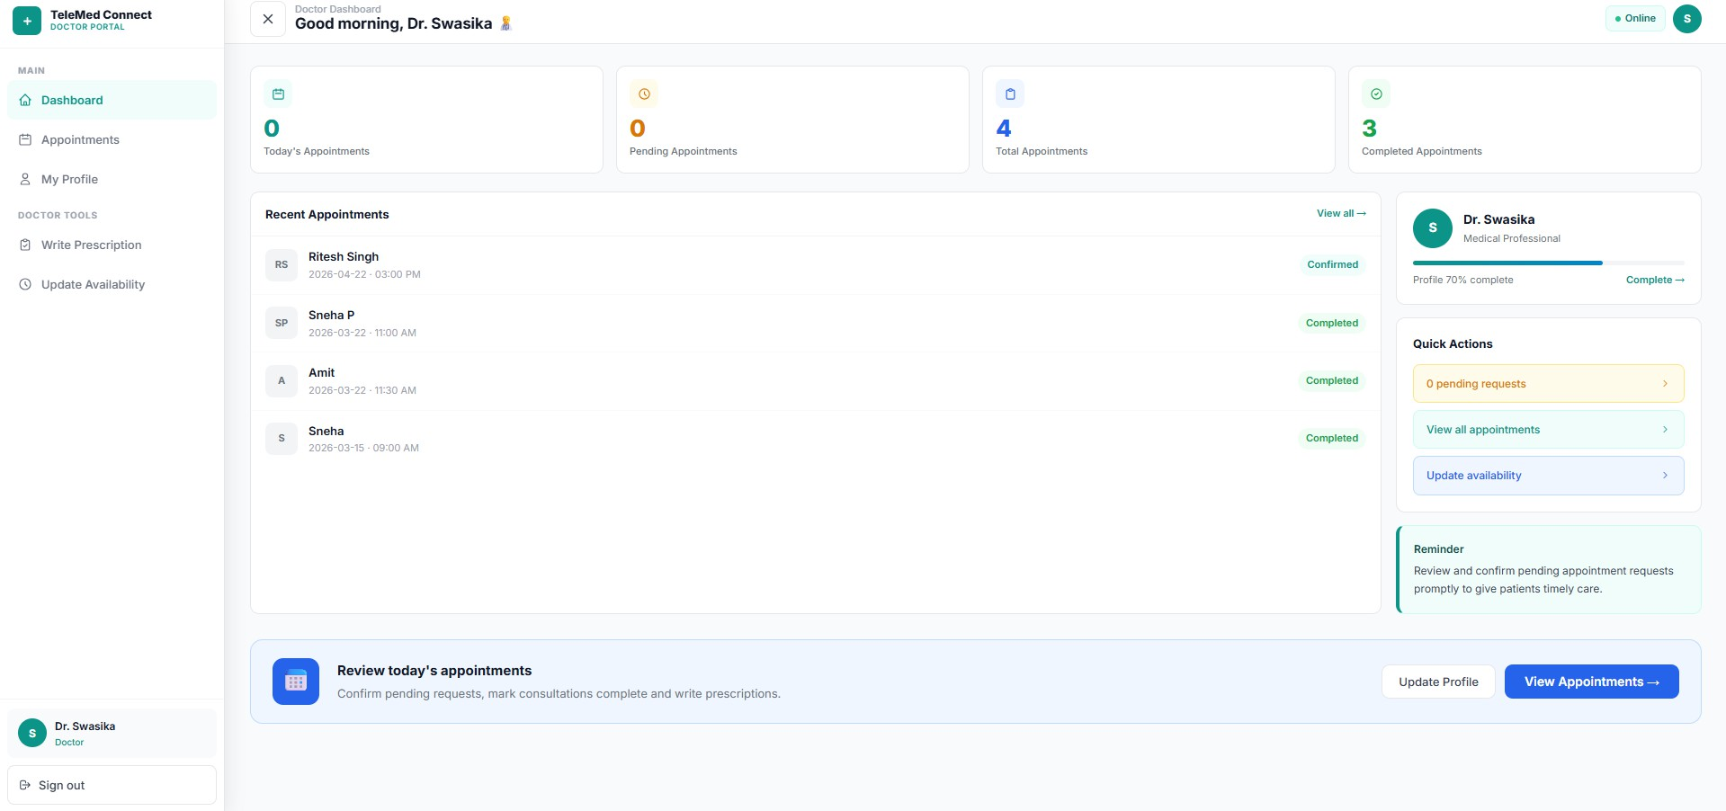

Figure 6: Book Appointment Interface
Enables patients to select date, time slot, and reason for consultation.

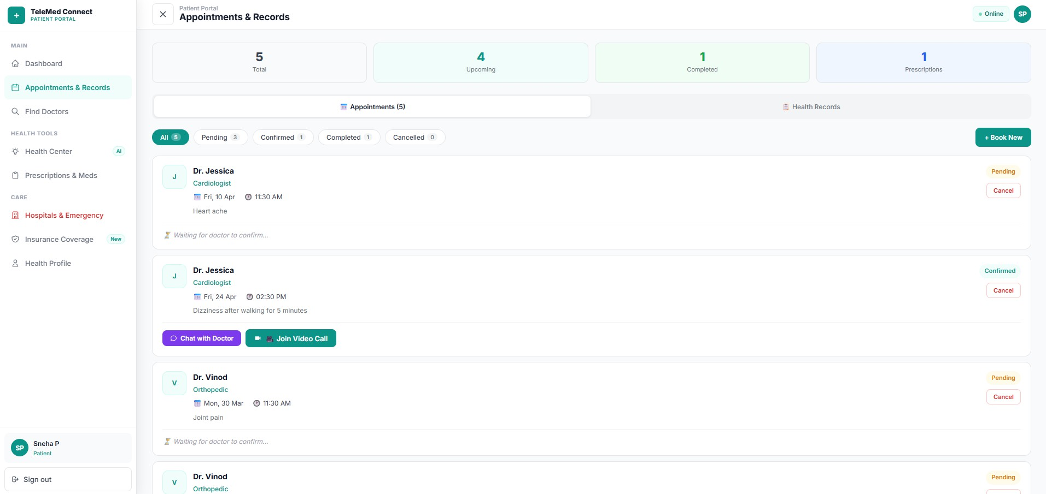
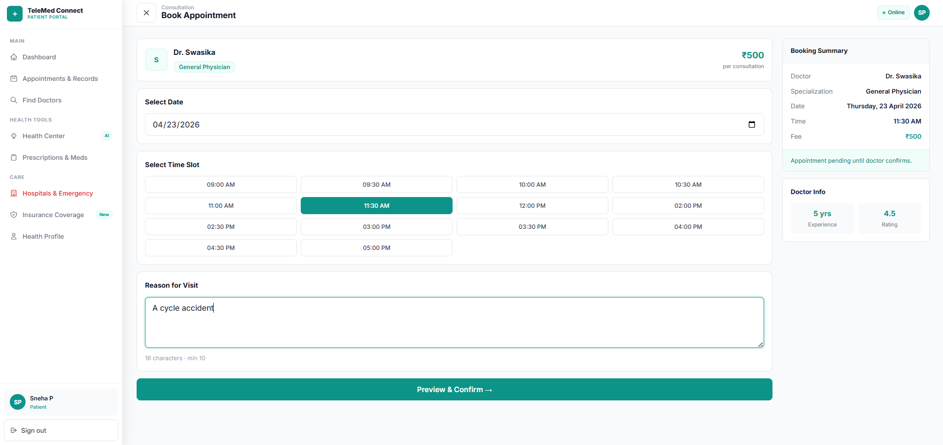

Figure 7: Razorpay Payment Gateway
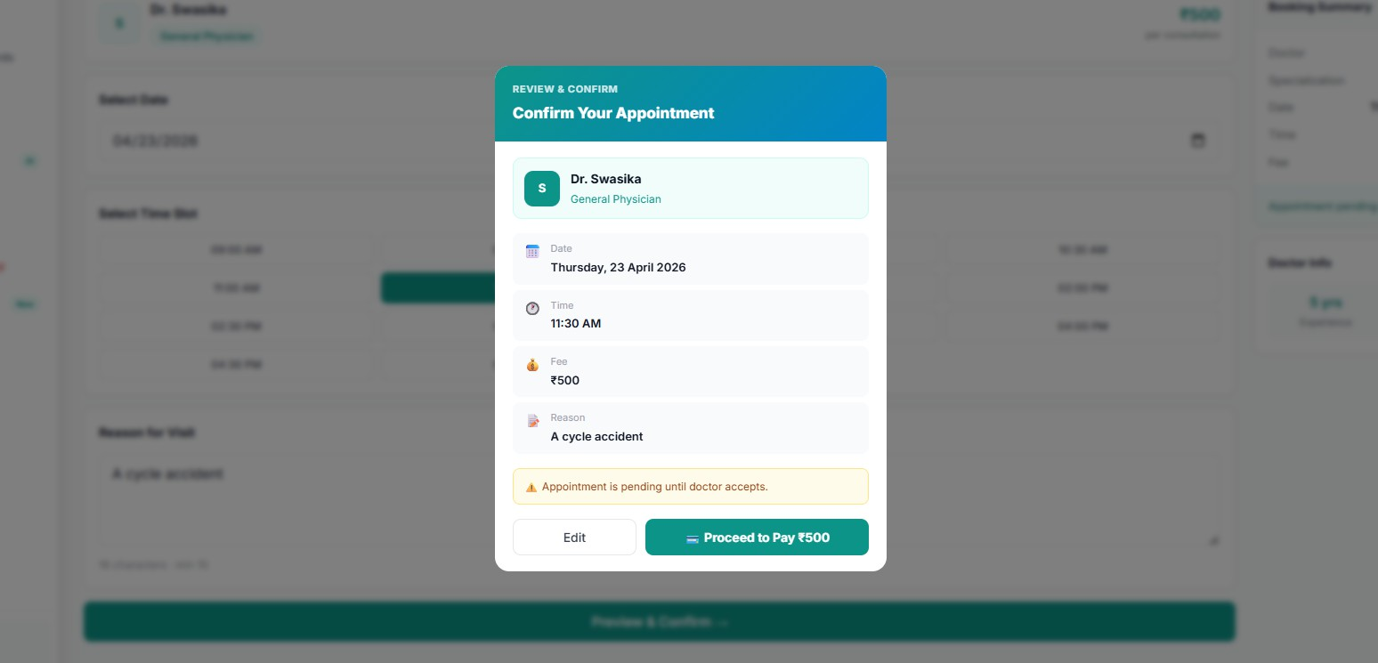
Secure payment interface for completing consultation booking.

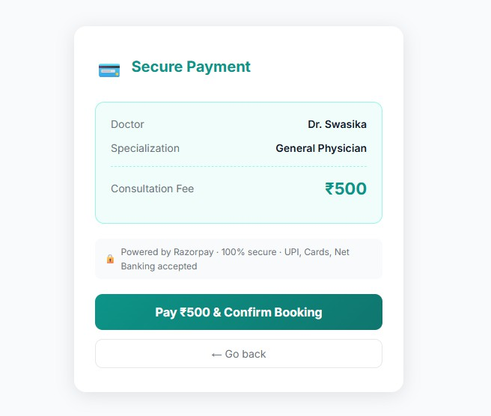
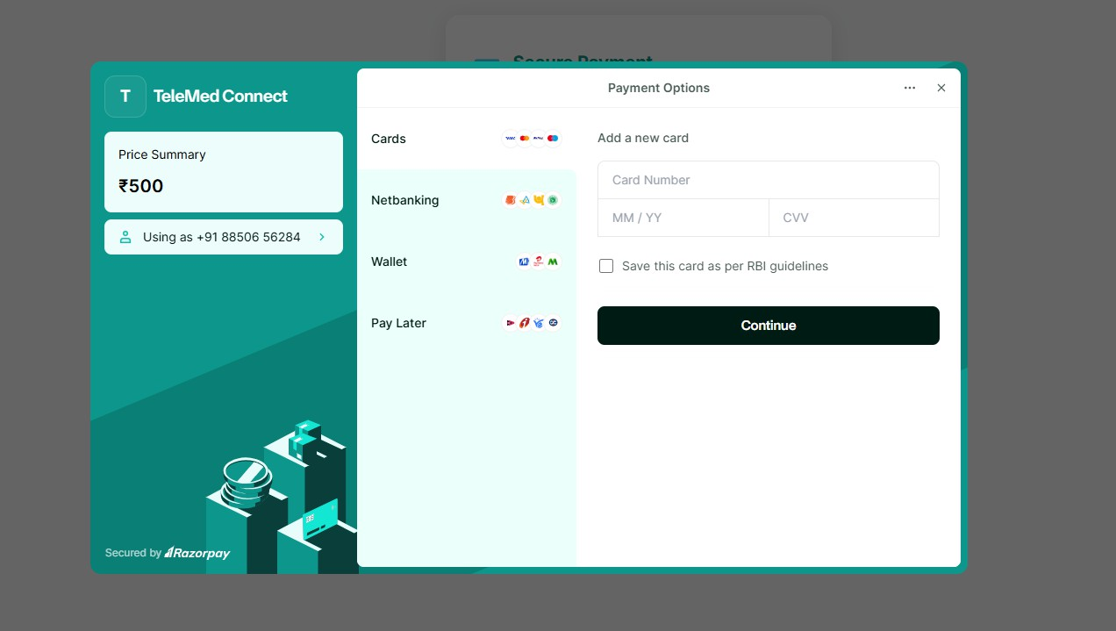

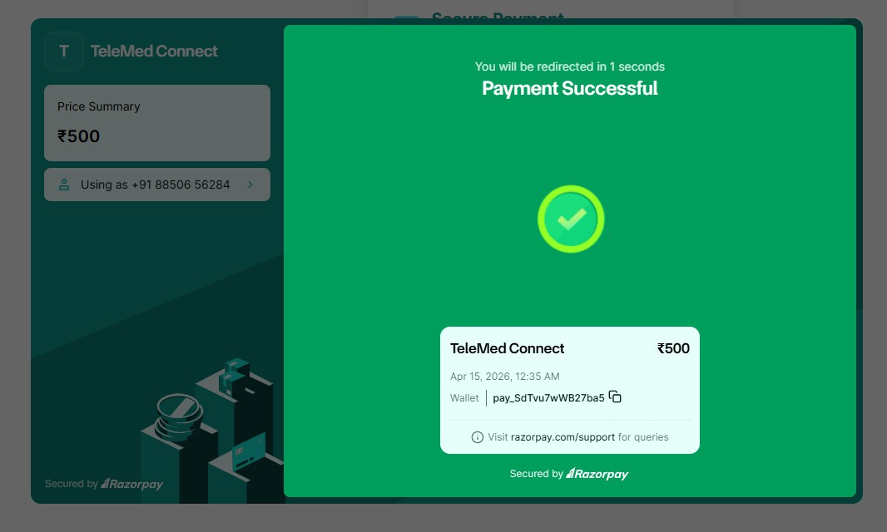
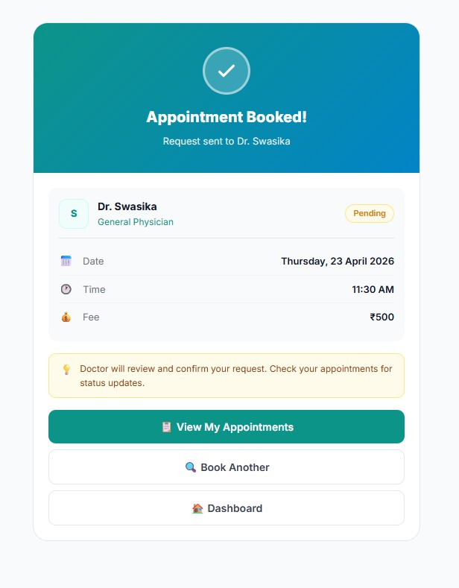

Figure 8: AI Symptom Checker Result
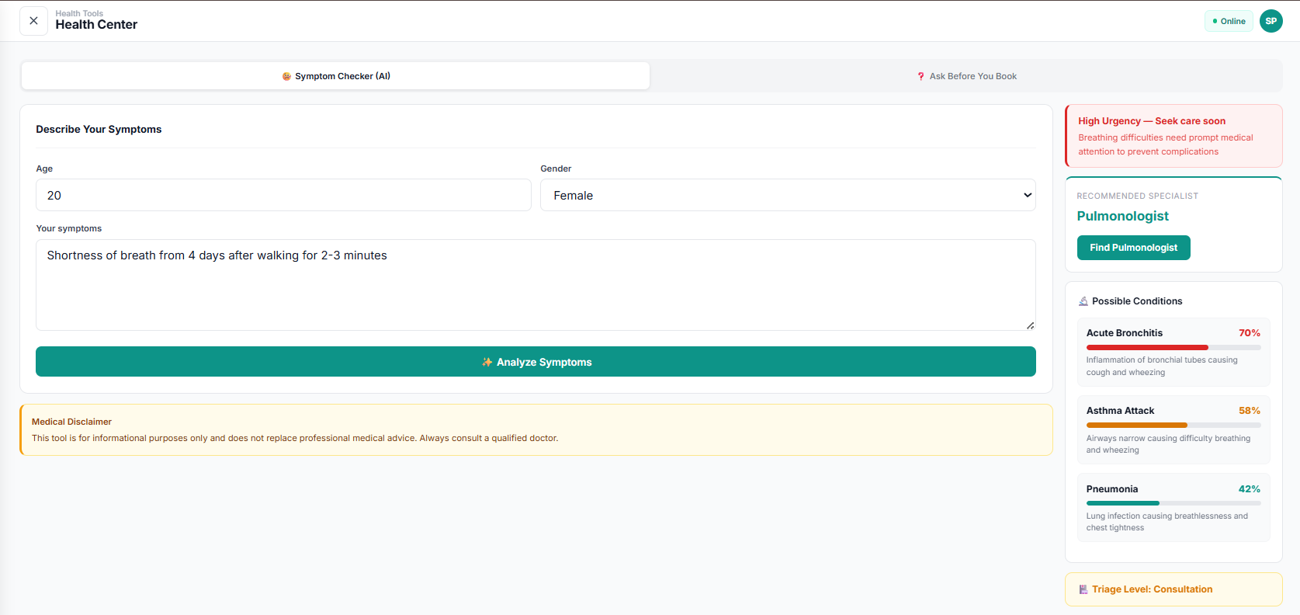
Displays predicted conditions with probability, remedies, and urgency level.

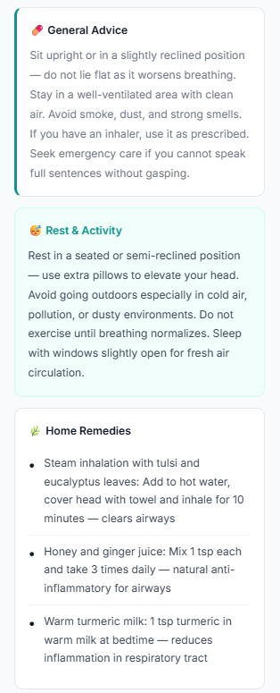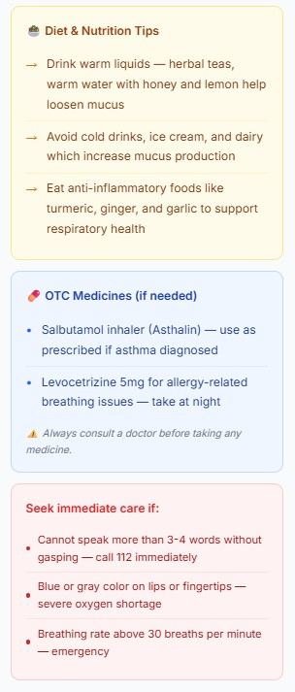

Figure 9: Multilingual Chat System
Real-time chat with automatic translation between patient and doctor.
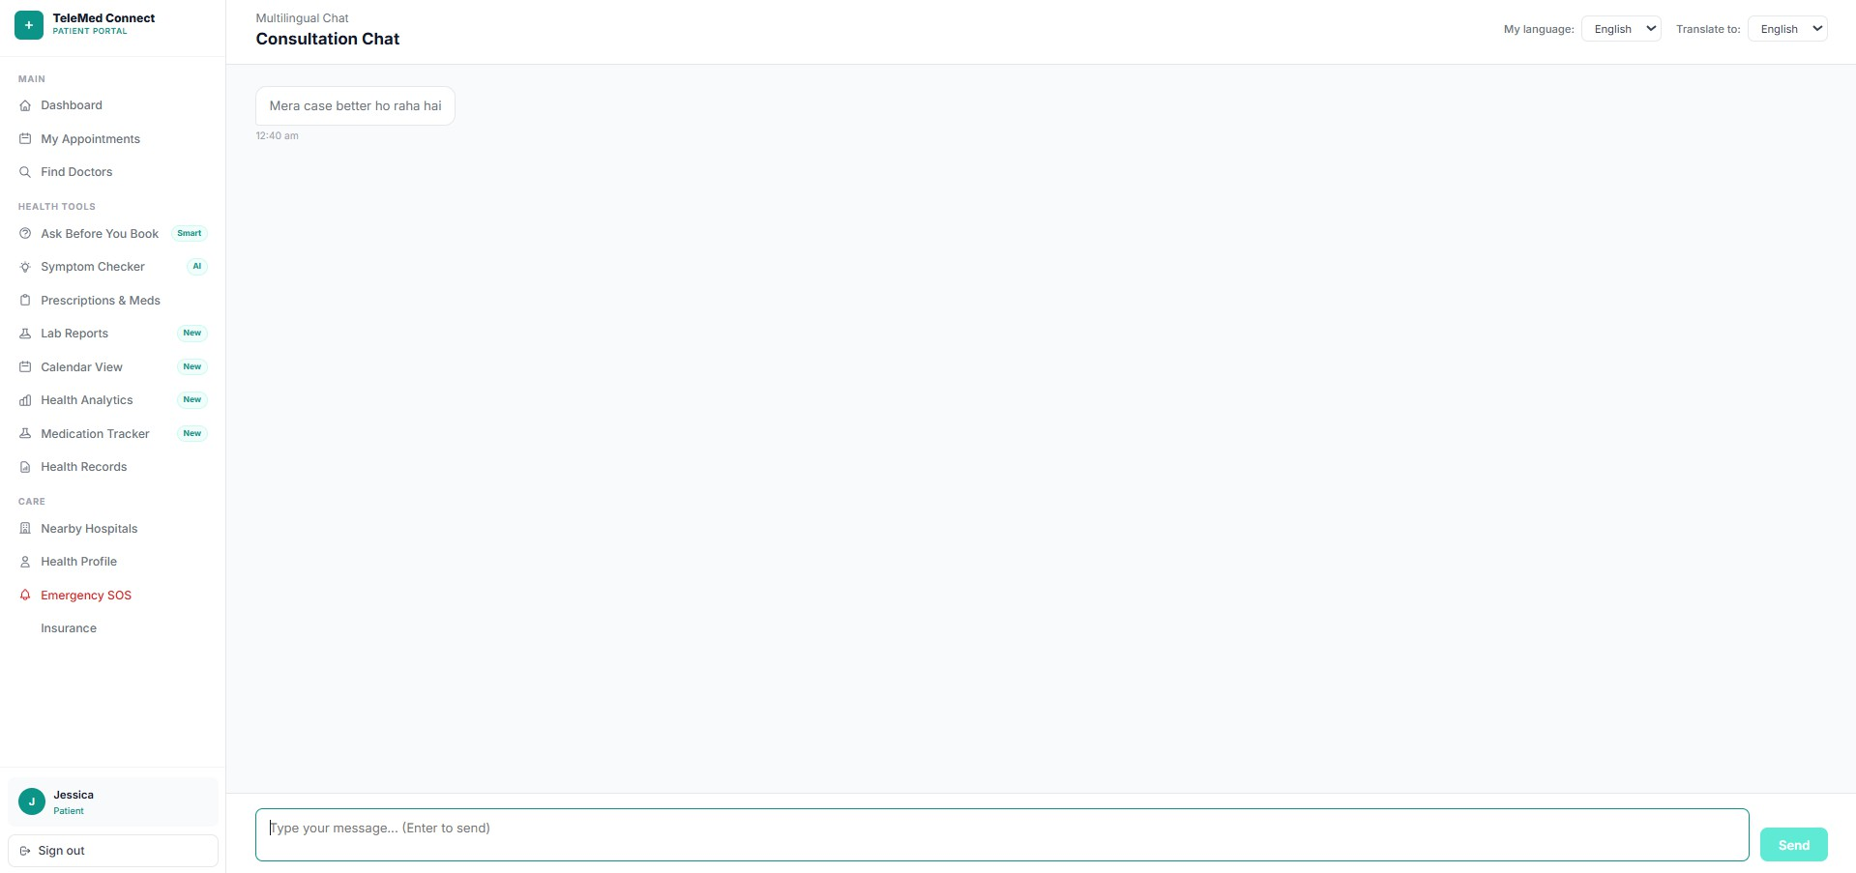

Figure 10: Video Consultation (Jitsi Meet)
Online video consultation interface for doctor-patient interaction.
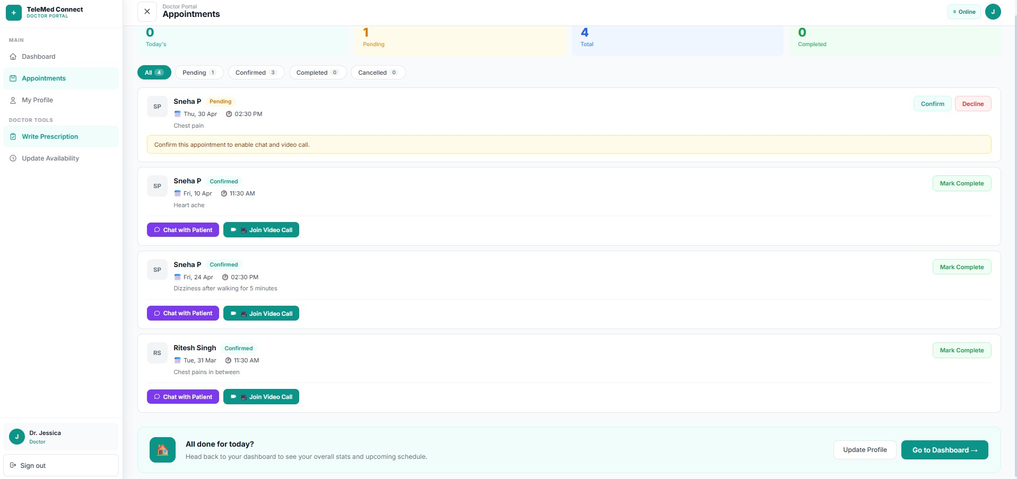

Figure 11: Emergency SOS Feature
Displays emergency activation with GPS location and helpline numbers.
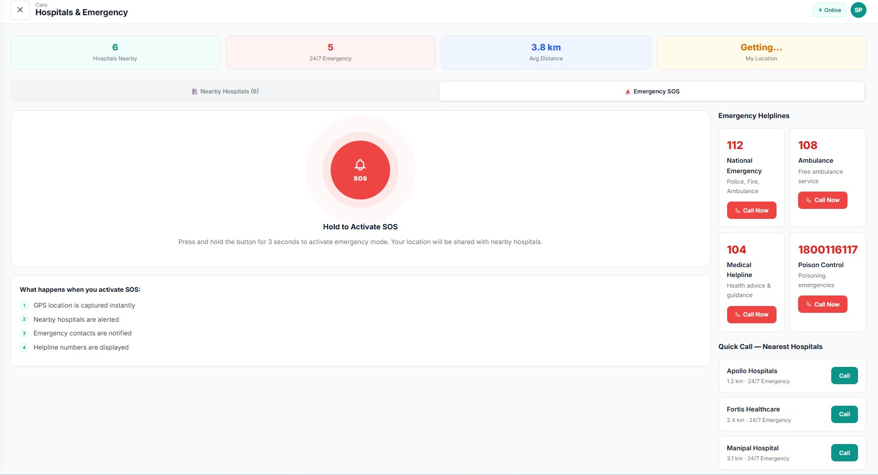

Figure 12: PDF Prescription Generation : Generated digital prescription with diagnosis and medicines for download.

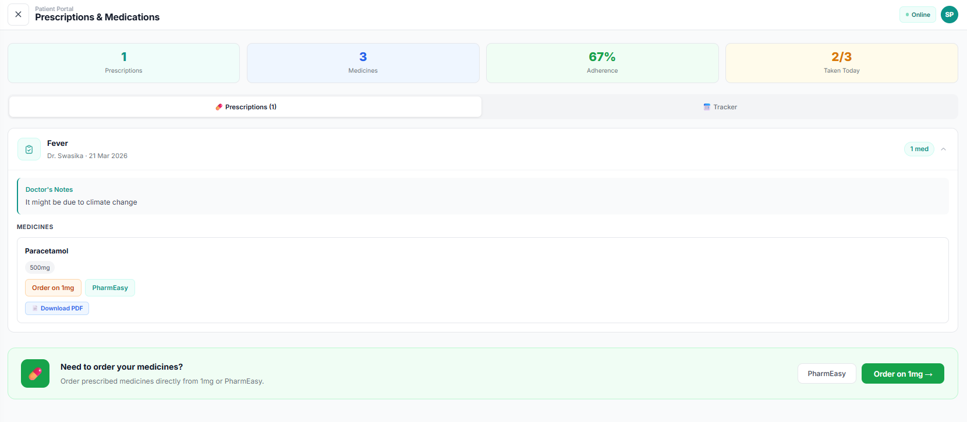
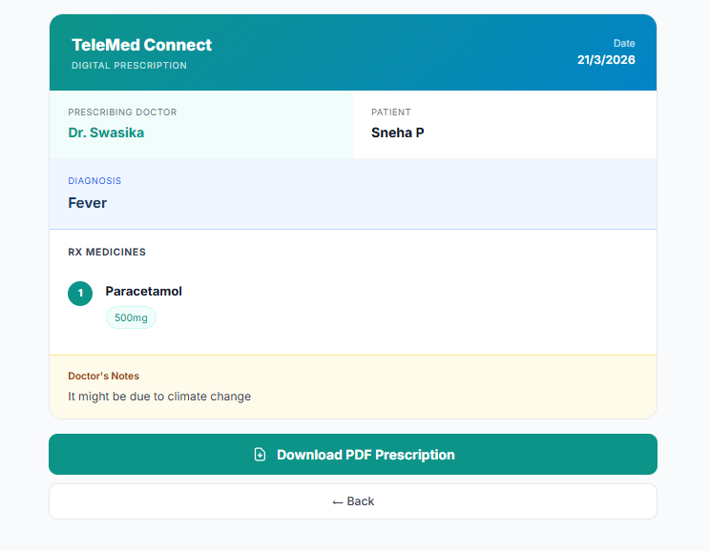

Figure 13: Lab Report Upload System
Allows patients to upload medical reports with progress tracking.

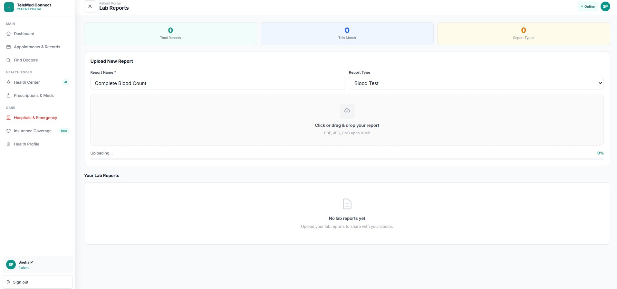

Figure 14: Doctor Reviews and Ratings
Displays patient feedback, ratings, and review distribution.
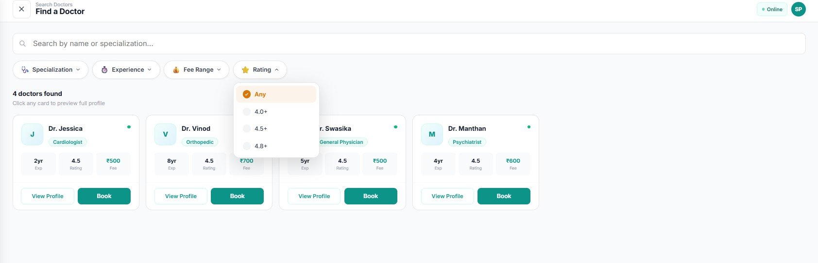

Figure 16: Appointment Calendar View
Monthly calendar displaying scheduled appointments with date-wise details.
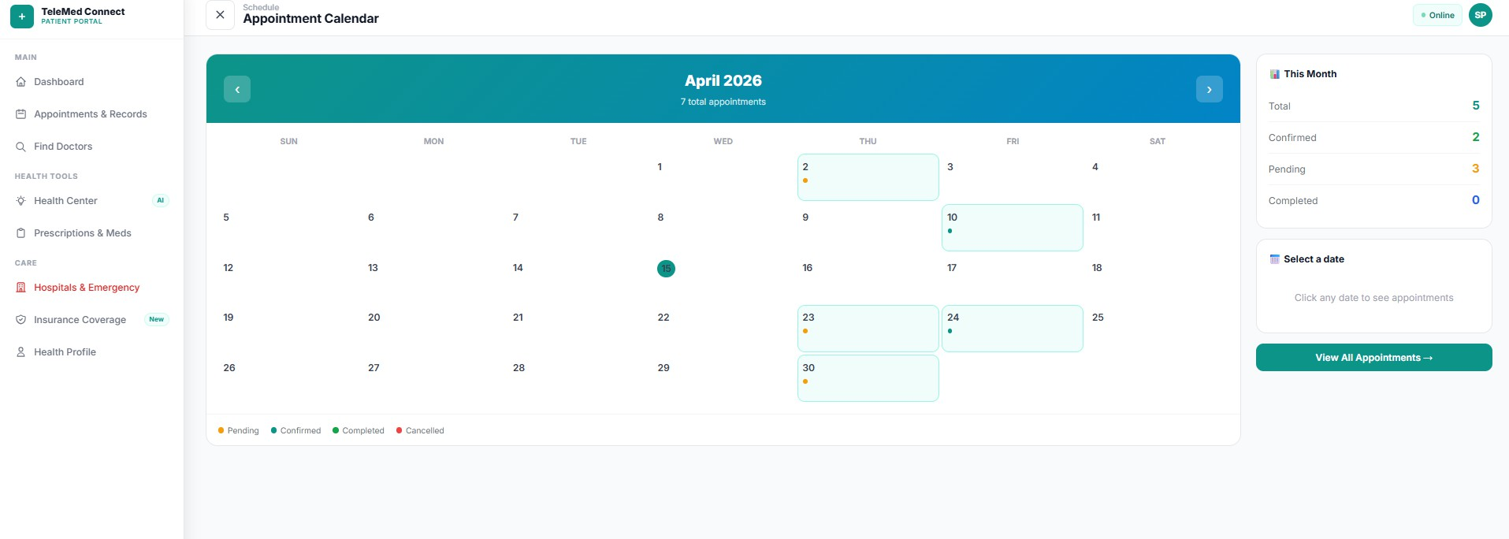

Figure 17: Health Analytics Dashboard
Visual representation of patient health data and appointment trends.
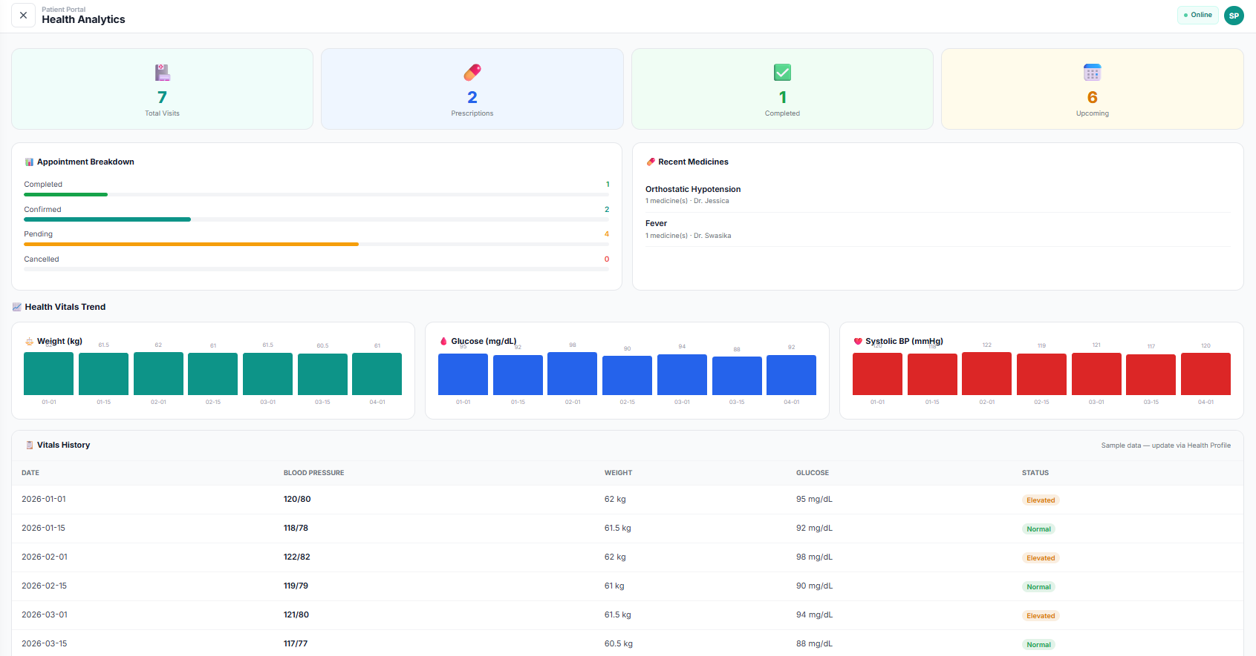

Web Programming Experiments Covered

Experiment | Concept | Implementation in TeleMed Connect
Experiment 1 | Semantic HTML | header (top bar), nav (sidebar), main (page content), article (appointment cards), aside (right panels), section (grouped content), time (appointment dates) — used across all pages
Experiment 2 | CSS Flexbox  + Grid + Selectors | Sidebar uses display:flex (column direction). Dashboard stat cards use display:grid (3 columns). CSS variable --color-primary:#0d9488. :hover and  :focus states on all interactive elements
Experiment 3 | Responsive Design + CSS Animations | 3 @media breakpoints in Layout.jsx. @keyframes fadeUp (card load), pulse (online dot), spin (loading). Hamburger button toggles sidebar.  prefers-reduced-motion accessibility query
Experiment 4 | Form Validation | BookAppointment.jsx: validateDate() checks past dates, validateTime() checks slot selected, validateReason() requires 10+ chars. All 3 run on onChange for real-time validation and on submit button click
Experiment 5 | Fetch API + JSON | Chat.jsx: fetch('https://api.mymemory.translated.net/get?q='+text+'&langpair=en|hi') returns JSON. await response.json() → data.responseData.translatedText extracted and saved to Firestore
Experiment 6 | Async/Await  + REST API | All Firebase calls use async/await with try/catch: const snap = await getDocs(query(...)). await addDoc(collection(db,'appointments'), {...}). await updateDoc(doc(db,'appointments',id), {status})

- Conclusion

TeleMed Connect is a fully deployed full-stack telemedicine platform that demonstrates practical application of all 6 Web Programming experiments. Unlike typical student projects that are UI-only mockups, TeleMed Connect has a real Firebase backend with live data, real payment integration, real video consultation, real file uploads, and real AI-powered symptom analysis.
The platform addresses a genuine societal problem — the healthcare access gap between urban and rural India — with a technically sound and feature-rich solution. The three unique features (Ask Before You Book, Emergency SOS with GPS, and Multilingual Chat) make TeleMed Connect distinctly different from existing commercial telemedicine platforms.

20+ Pages | 8+ APIs | 6/6 Experiments | Live Deployed
Full patient + doctor + admin portal | Firebase, Razorpay, Jitsi, MyMemory, jsPDF, Gemini, Geolocation | HTML, CSS, Flexbox, Validation, Fetch, Async/Await | https://telemed-connect  -6e817.web.app

Built with dedication by Team TeleMed Connect
Sneha Pillai | Amit | Mudassir | Ritesh
Pillai College of Engineering | ENGG201 — Web Programming | 2025-26

